**Fee Report | Student Management System in Java**

### Objective/ Vision

A fee report software where admin can add/view/delete accountant and accountant can add/view/edit/delete student, check due fee and logout.

### Users of the System

1. Admin
2. Accountant

### Functional Requirements

**1. Admin**

1. Can add/view/edit/delete accountant
2. Can logout

**2. Accountant**

1. Can add/view/edit/delete students
2. Can check due fee
3. Can logout

### Tools to be used

1. Use any IDE to develop the project. It may be Eclipse /Myeclipse / Netbeans etc.
2. MySQL for the database.

### Front End and Back End

1. **Front End:** Java Swing
2. **Back End:** MySQL

### How project works?

To get detail explanation about project, download the document file. It includes snapshots with explanation.

Some screenshots are given below:

Run FeeReport class

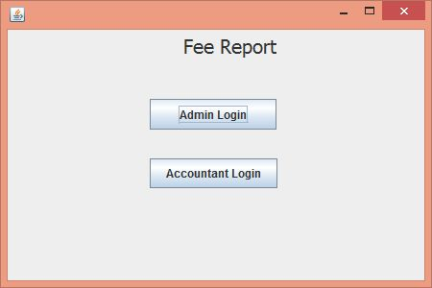

Click on Admin Login

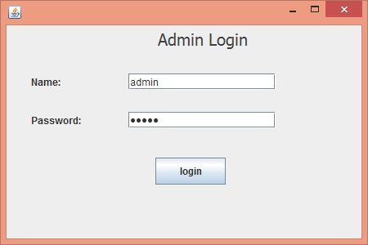

Name is: admin

Password is: admin123

click on login button, it will open Admin Section

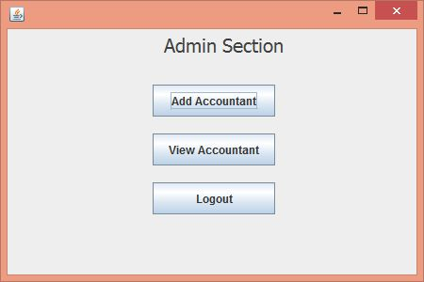

Click on Add Accountant

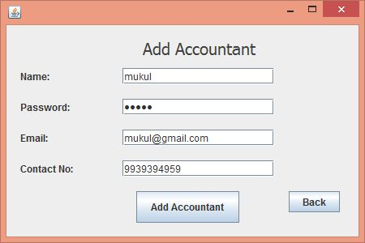

After adding accountant, click on back button.

Now click on View Accountant.

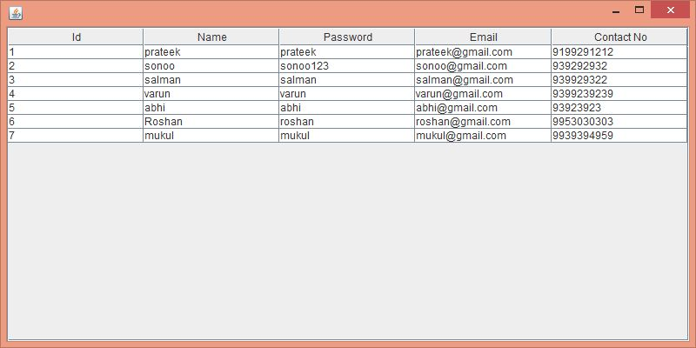

Now click on logout

Click on Accountant Login

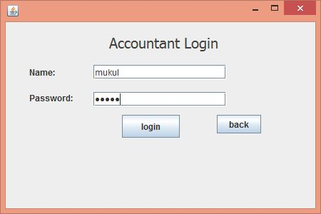

Use the name and password which you stored in database.

Click on login button.

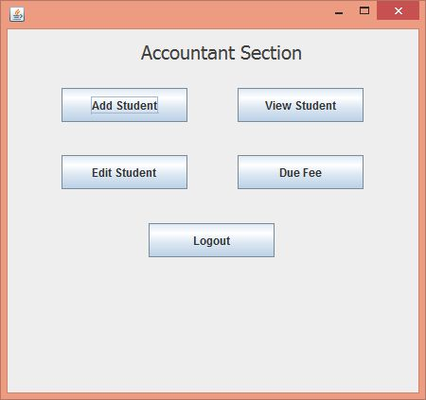

Click on Add Student

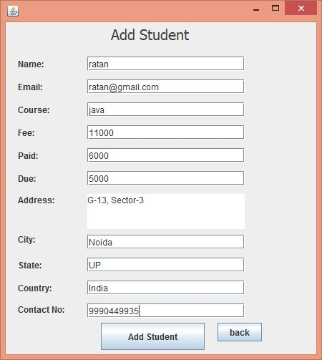

Fill information and click on Add Student

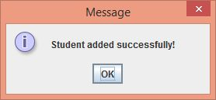

Click on ok. Now View Student.

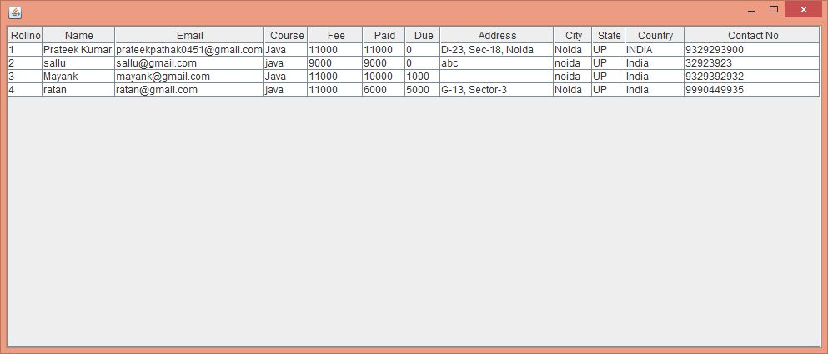

Now, click on edit button.

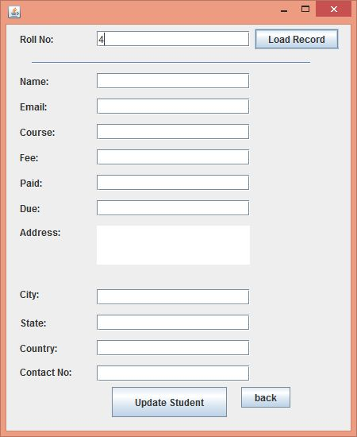

Enter rollno and click on load record.

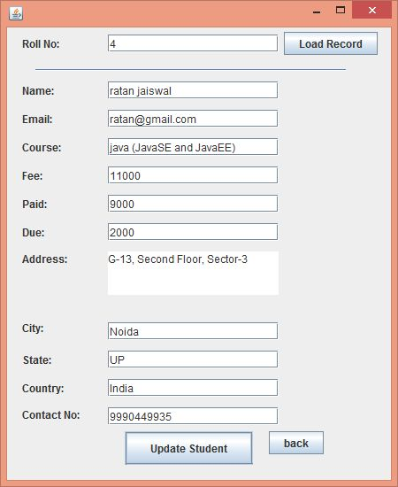

Update information and click on Update Student.

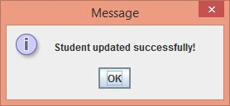

Click on ok button. Now View due fee.

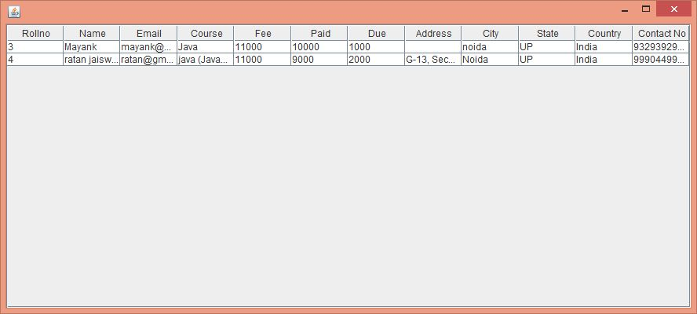

Now logout.

### How to run this project

Import sql files to create tables in mysql.

Import the project on the Eclipse IDE and run it.